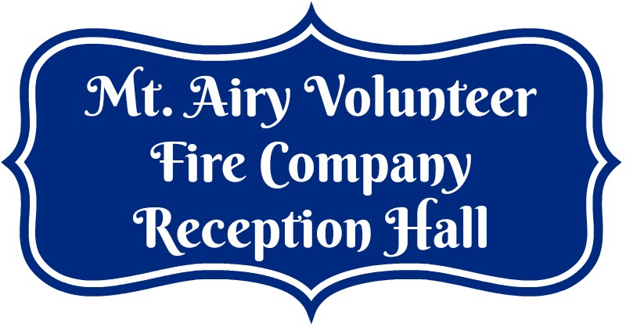
Venue Checklist

Below is a checklist to help you select the perfect venue for your event.

 | MAVFC Reception Hall | Venue 2 | Venue 3
Venue Capacity | 266
Dance Floor | Yes
Outdoor ceremony area | Yes
Tables & Chairs included | Yes
# of hours included in the rental | 18 hours
Security Deposit | Yes - $300
A/C & Heat all year | Yes
On-site parking | Yes
How many toilets | 4 in each bathroom
Are You Required to Use Specific Vendors? | No
Can I bring my own food? | Yes
Can I bring alcohol? | Yes
Do I need an alcohol license? | No
Rate | $775 Fri, Sat or Sun  $400 Mon - Thurs
Are any other events booked on the same day as our event? | No
Does the venue have liability insurance? | Yes
Handicap accessible? | Yes from 2 entrances

